# Lab: Interfaces and Abstraction

Problems for the ["C# OOP" course @ SoftUni"](https://softuni.bg/trainings/3585/csharp-oop-february-2022).

You can check your solutions here: <https://judge.softuni.org/Contests/1501/Interfaces-and-Abstraction-Lab>

## Shapes

**NOTE**: You need a public StartUp class with the namespace Shapes.

Build a **hierarchy** of **interfaces** and **classes**:

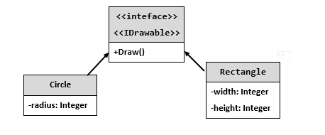

You should be able to use the class like this:

|  |
| --- |
| StartUp.cs |
| var radius = int.Parse(Console.ReadLine());  IDrawable circle = new Circle(radius);  var width = int.Parse(Console.ReadLine());  var height = int.Parse(Console.ReadLine());  IDrawable rect = new Rectangle(width, height);  circle.Draw();  rect.Draw(); |

### Examples

|  |  |
| --- | --- |
| **Input** | **Output** |
| 3  4  5 | *******  ** **  ** **  * *  ** **  ** **  *******  ****  * *  * *  * *  **** |

### Solution

The algorithm for drawing a circle is:

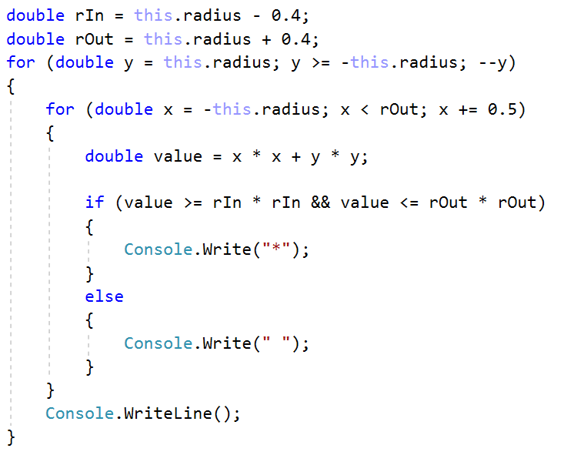

The algorithm for drawing a rectangle is:

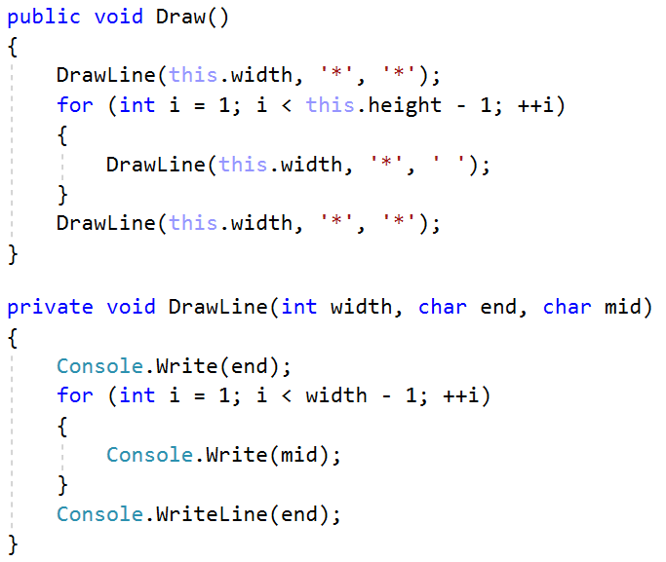

## Cars

**NOTE**: You need a public StartUp class with the namespace Cars.

Build a **hierarchy** of **interfaces** and **classes**:

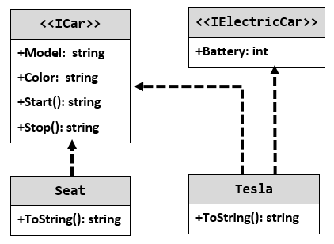

Your hierarchy must be used with this code:

|  |
| --- |
| StartUp.cs |
| ICar seat = new Seat("Leon", "Grey");  ICar tesla = new Tesla("Model 3", "Red", 2);  Console.WriteLine(seat.ToString());  Console.WriteLine(tesla.ToString()); |

### Examples

|  |
| --- |
| **Output** |
| Grey Seat Leon  Engine start  Breaaak!  Red Tesla Model 3 with 2 Batteries Engine start  Breaaak! |